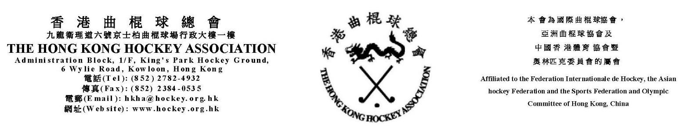

THE HONG KONG HOCKEY ASSOCIATION
WOMEN’S SECTION

ANNUAL GENERAL MEETING

At 7:30pm

Monday 29th June 2020

Hong Kong Football Club

AGENDA

1. | Apologies
2. | To pass the minutes of previous AGM
3. | Chairwoman & Committee reports
4. | Treasurer’s report
5. | Election of Office Bearers
6. | Any other business

